**Hot Spot Analysis**

Hotspot Analysis uses vectors to identify locations of statistically significant hot spots and cold spots in your data by aggregating points of occurrence into polygons or converging points that are in proximity to one another based on a calculated distance. The analysis groups features when similar high (hot) or low (cold) values are found in a cluster. The polygons usually represent administration boundaries or a custom grid structure.

The Hot Spot Analysis tool calculates the Getis-Ord Gi* statistic (pronounced G-i-star) for each feature in a dataset. The resultant z-scores and p-values tell us where features with either high or low values cluster spatially. This tool works by looking at each feature within the context of neighbouring features. A feature with a high value is interesting but may not be a statistically significant hot spot. To be a statistically significant hot spot, a feature will have a high value and be surrounded by other features with high values as well. The local sum for a feature and its neighbours is compared proportionally to the sum of all features; when the local sum is very different from the expected local sum, and when that difference is too large to be the result of random chance, a statistically significant z-score results. When the FDR correction is applied, statistical significance is adjusted to account for multiple testing and spatial dependency.

The Gi* statistic returned for each feature in the dataset is **a z-score**. Z-scores are standard deviations. If, for example, an analysis returns a z-score of +2.5, we would say that the result is 2.5 standard deviations. For statistically significant positive z-scores, the larger the z-score is, the more intense the clustering of high values (hot spot). For statistically significant negative z-scores, the smaller the z-score is, the more intense the clustering of low values (cold spot).

The **p-value** is a probability. For the pattern analysis tools, it is the probability that the observed spatial pattern was created by some random process. When the p-value is very small, it means it is very unlikely (small probability) that the observed spatial pattern is the result of random processes, so you can reject the null hypothesis.

Both z-scores and p-values are associated with the standard normal distribution as shown below in Figure xx.

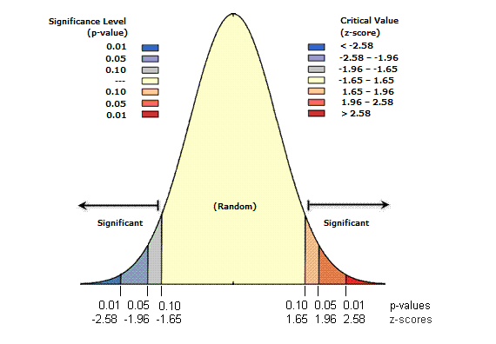

Very high or very low (negative) z-scores, associated with very small p-values, are found in the tails of the normal distribution. When we run a feature pattern analysis tool and it yields small p-values and either a very high or a very low z-score, this indicates it is unlikely that the observed spatial pattern reflects the theoretical random pattern represented by our null hypothesis (CSR).

Classical Interpretation of the results looks like:

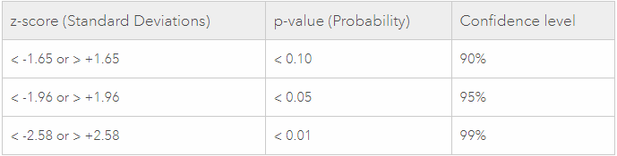

In this part, some of the approaches for Hot/Cold Spot analysis will be presented for each of three project cities: Vienna (Austria), Munich (Germany) and Brussels (Belgium).

Since this is possible to use different approaches for conduction of Hot/Cold Spot analysis, it makes sense to experiment with some of them and compare the results in order to understand the patterns and to pick out the most representative approaches. For doing this, eleven different approaches were used for one of the three cities - Vienna.

Since any approach for getting hot/cold spots is based on comparing the point with respect to it’s neighbours, the next several approaches are based on the point distance to it’s neighbours of 250 meters. Further, the results will be represented together with their interpretation.

**Hot/Cold Spot Analysis for Vienna**

1. The result depicted in Figure xx is the result of the **classical Hot Spot / Cold analysis (Getis-Ord Gi*)**.

This analysis based on the raw point data with point distance to it’s of 250 meters.

Important to mention, if a chosen scale for the analysis is small, even though there are features around with low values, it is definitely conceivable that a feature with a very high value shows up as a hot spot even though it is surrounded by low values (essentially the value of the feature is so high that it brings the local mean up).

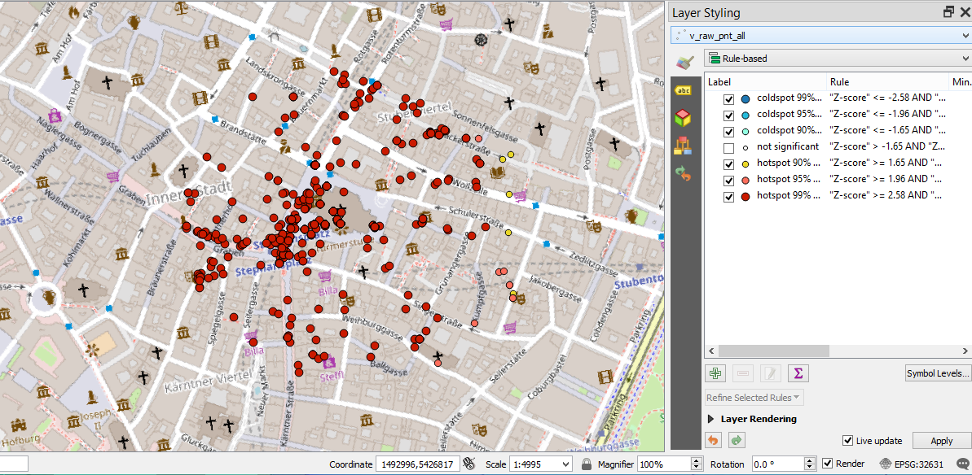

Interpretation:

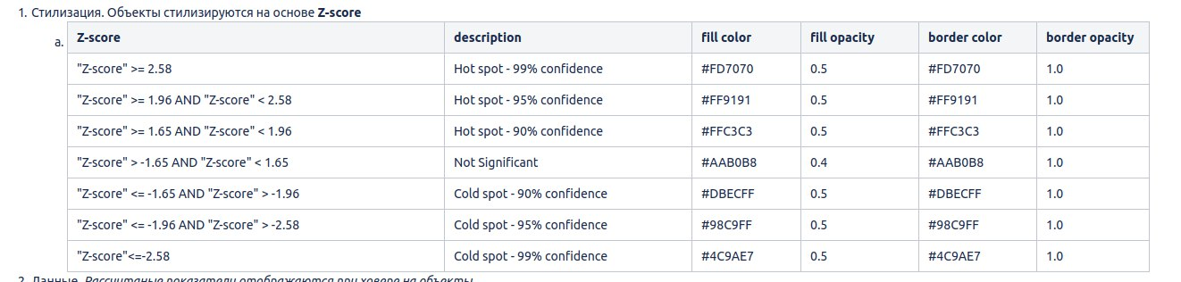

2. The result represented in Figure xx is the result of **Local Moran's I analysis**.

This is the analysis of clusters of high and low values and outliers, based on raw point data with point distance to it’s neighbours of 250 meters.

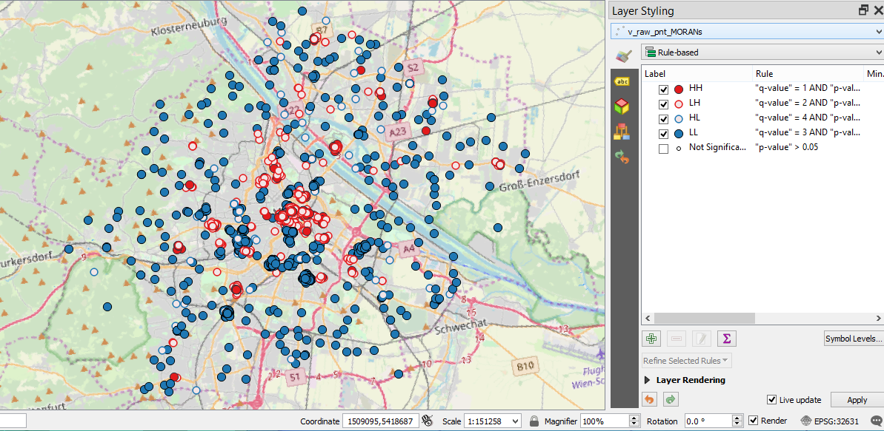

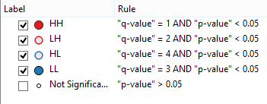

“HH” - obvious hot spots

“LH” and “HL” - outliers (abnormal values)

“LH” - low values surrounded by high values

“HL” - high values surrounded by low values

“LL” - obvious cold spots

There is the difference between classical Hot Spot analysis and Local Moran’s I. First of, it is important to understand that these two methods, Local Moran's I and Getis-Ord Gi*, while they are similar in terms of the types of questions that they answer, have some key differences that can explain why you would get such different results. The main difference is that for Local Moran's I, when doing the analysis for each individual feature, the value of the feature being analyzed is NOT included in that analysis, only the neighbouring values are. Alternatively, when the local analysis is being done with Getis-Ord Gi*, the value of each feature is included in its own analysis. In other words, the local mean for Moran's I includes only neighbouring features, whereas the local mean for Getis-Ord Gi* includes all features.

1. Figure xx depicts the result of Hot / Cold Spot analysis based on **grid (MultiPolygon)** of 250 meters only for **negative emotions**.

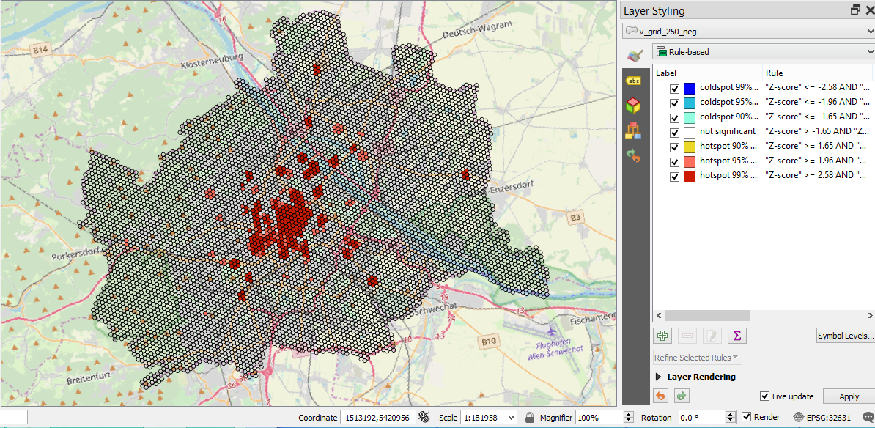

4. Figure xx depicts the result of Hot / Cold Spot analysis based on **grid (MultiPolygon)** of 250 meters only for **positive emotions**.

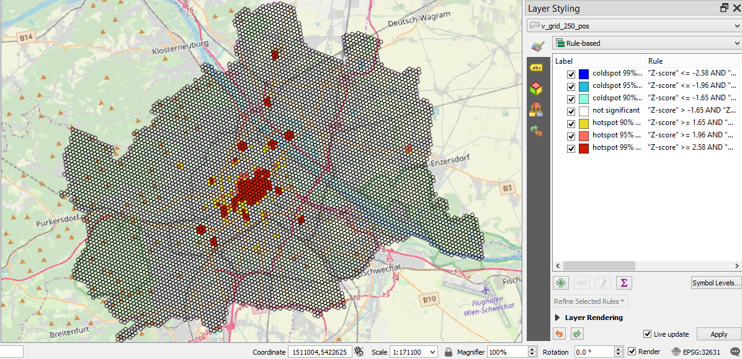

5. Figure xx shows the result of Hot / Cold Spot analysis based on **grid (MultiPolygon)** of 500 meters only for **negative emotions**.

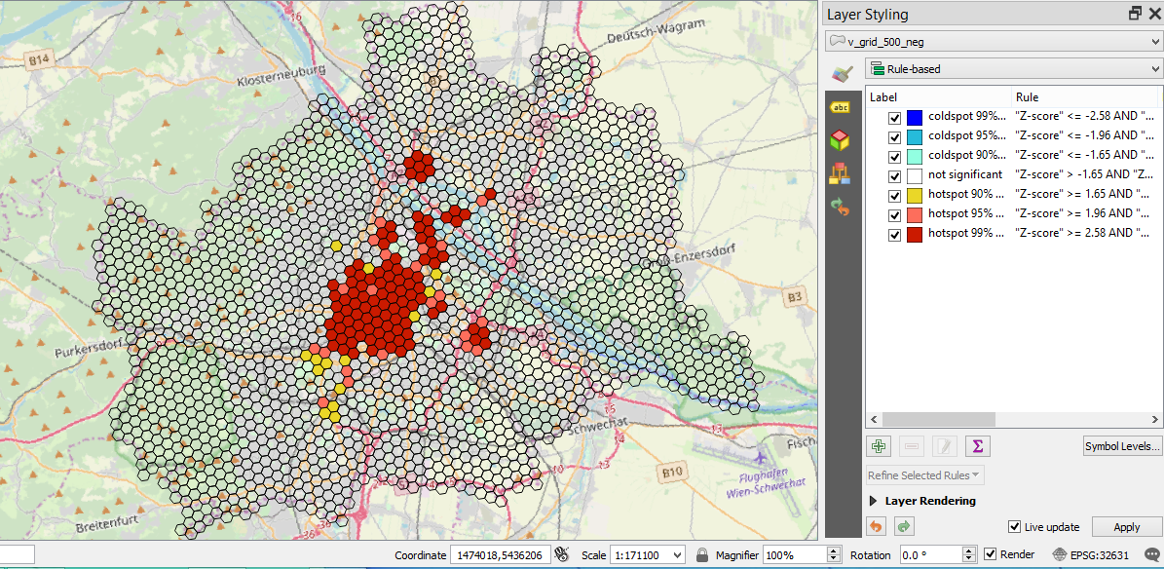

6. Figure xx presents the result of Hot / Cold Spot analysis based on **grid (MultiPolygon)** of 500 meters only for **positive emotions**.

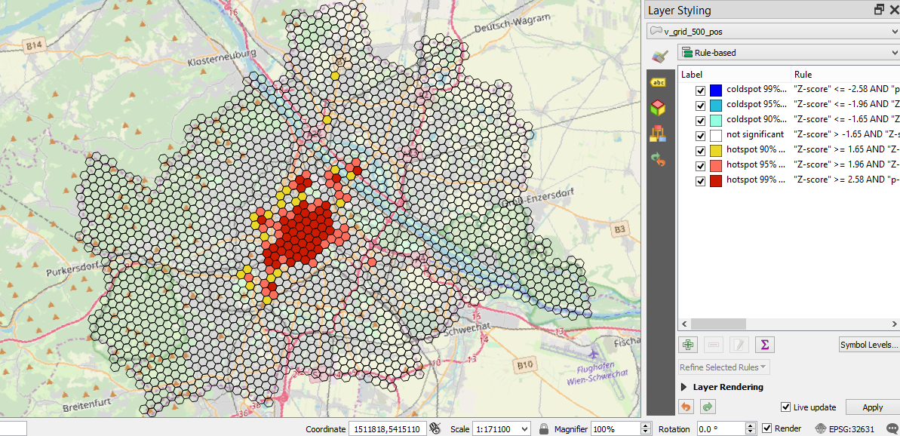

7. Figure xx presents the result of Hot / Cold Spot analysis based on **statistical units (districts)** only for **negative emotions**.

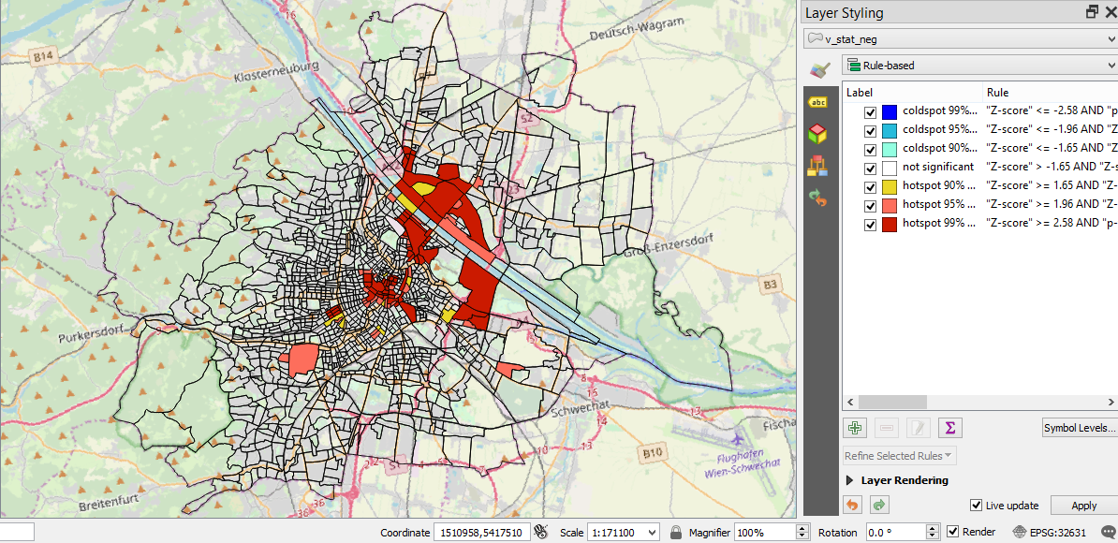

8. Figure xx presents the result of Hot / Cold Spot analysis based on **statistical units (districts)** only for **positive emotions**.

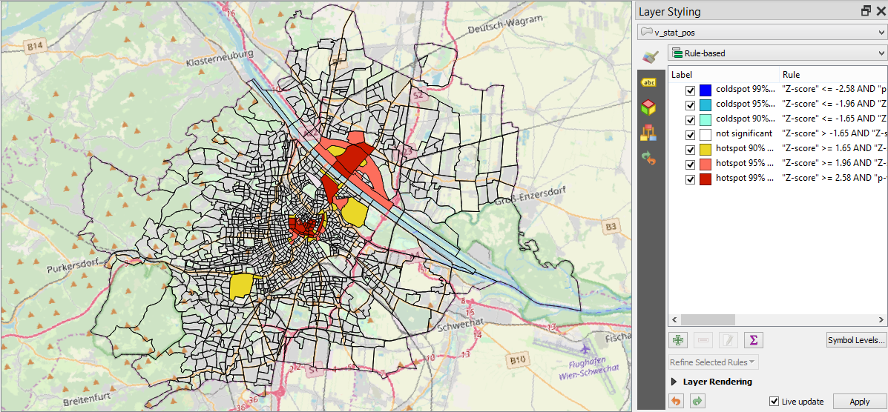

Statistical unit analysis for both negative and positive emotions is based on unique homogeneous blocks of elements. This approach shows how homogeneous conditions promote the appearance of positive/negative tweets in different units. But there is a significant drawback of using the aggregated grid: it returns not really correct results. For instance, this is obviously that the biggest amount of tweets is concentrated in the city centre, hence there will be more positive tweets in the city centre in comparison to other city districts.

In such a case it makes sense to conduct **analysis based on grid**. Grid analysis prescinds from division of the territory into separate units. Here the territory is considered as a “united canvas”.

9. The result depicted in Figure xx is based on **standard deviation** (diversity indicator) analysis with grid of 250 meters.

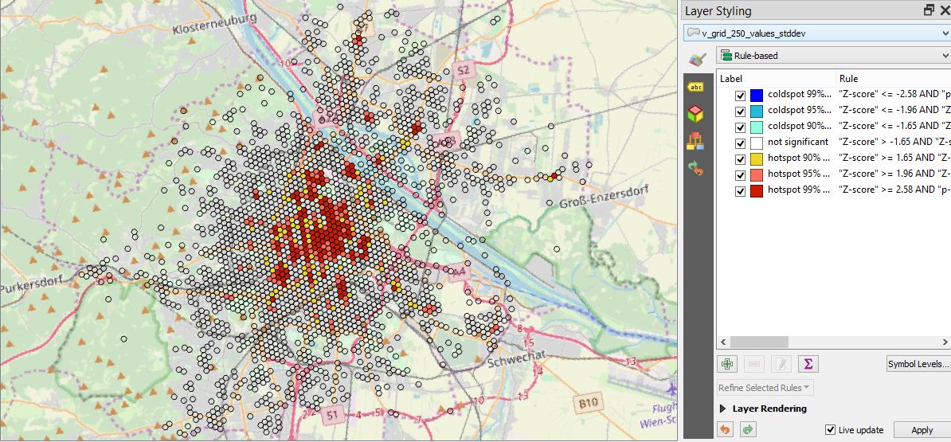

10. The result represented in Figure xx is based on **median** analysis with grid of 250 meters.

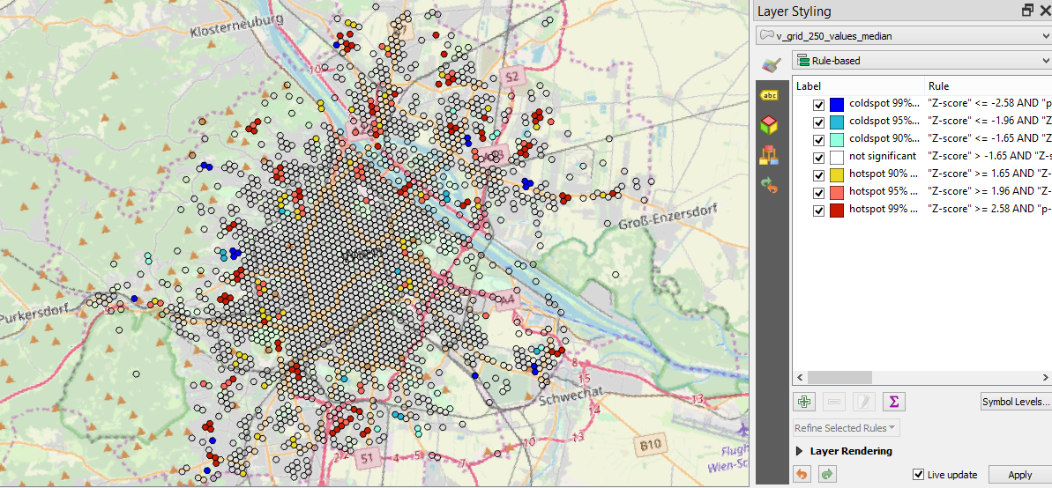

11. The result represented in Figure xx is based on **mean** (average)analysis with grid of 250 meters.

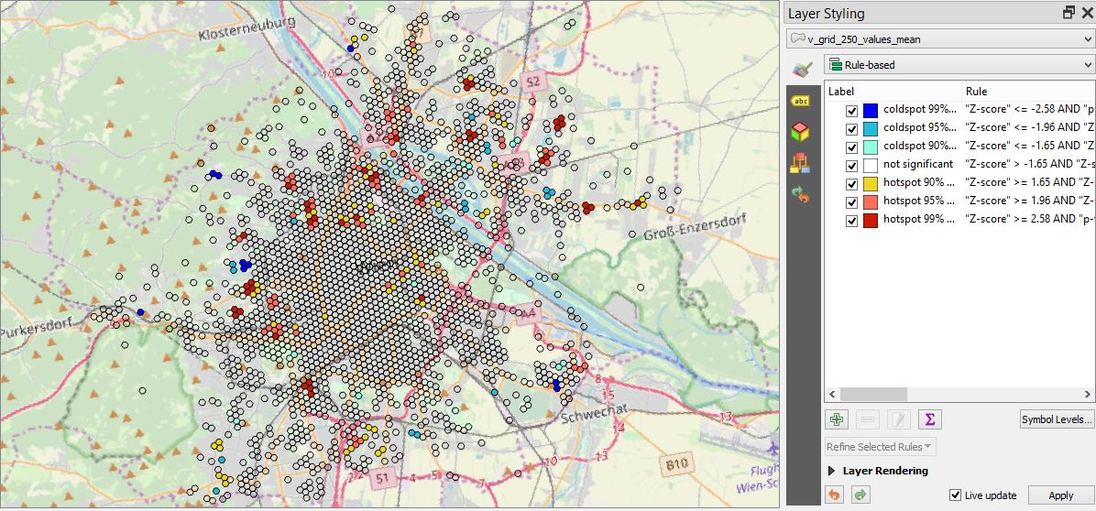

After experimenting with different analysis approaches for Vienna data, it was decided to focus on not the only one analysis approach for other cities, but on four of them: **Statistical Units analysis** (positive & negative emotions separately), **Local Moran’s I analysis** and **Standard Deviation analysis** based on grid. The main purpose for that is confirmation of the fact there is no only one correct approach for Hot Spot/Cold analysis. It always makes sense to focus on several approaches in order to make reliable and representative decisions.

**Hot/Cold Spot Analysis for Brussels**

1. The result represented in Figure xx is the result of **Local Moran's I analysis**.

This is the analysis of clusters of high and low values and outliers, based on raw point data with point distance to it’s neighbours of 250 meters.

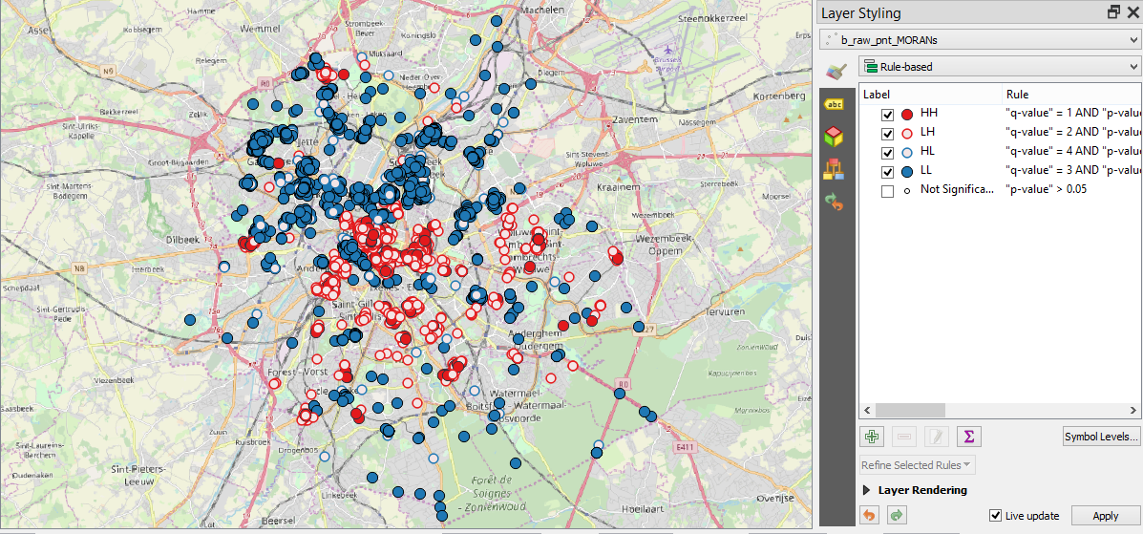

2. Figure xx presents the result of Hot / Cold Spot analysis based on **statistical units (districts)** only for **positive emotions**.

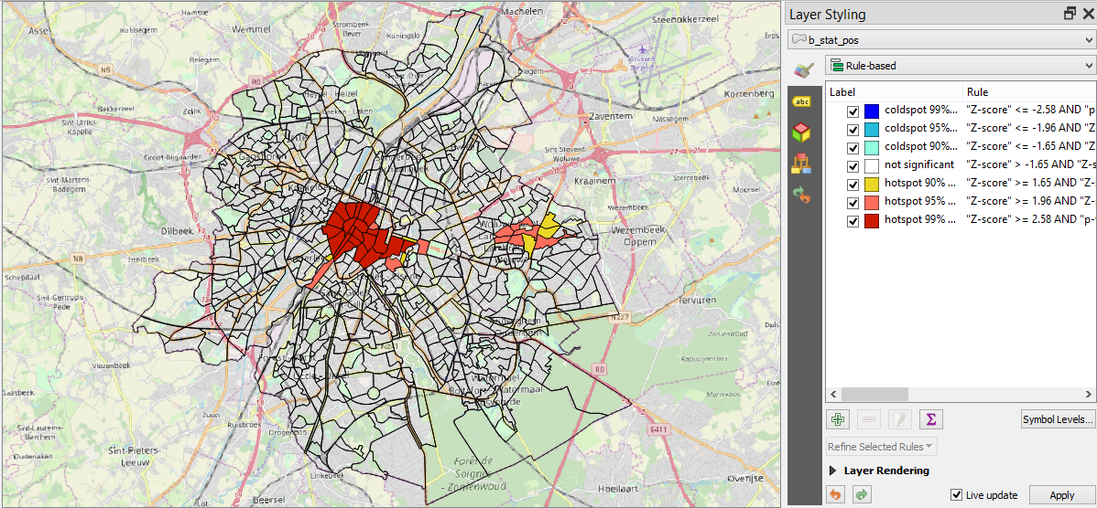

3. Figure xx presents the result of Hot / Cold Spot analysis based on **statistical units (districts)** only for **negative emotions**.

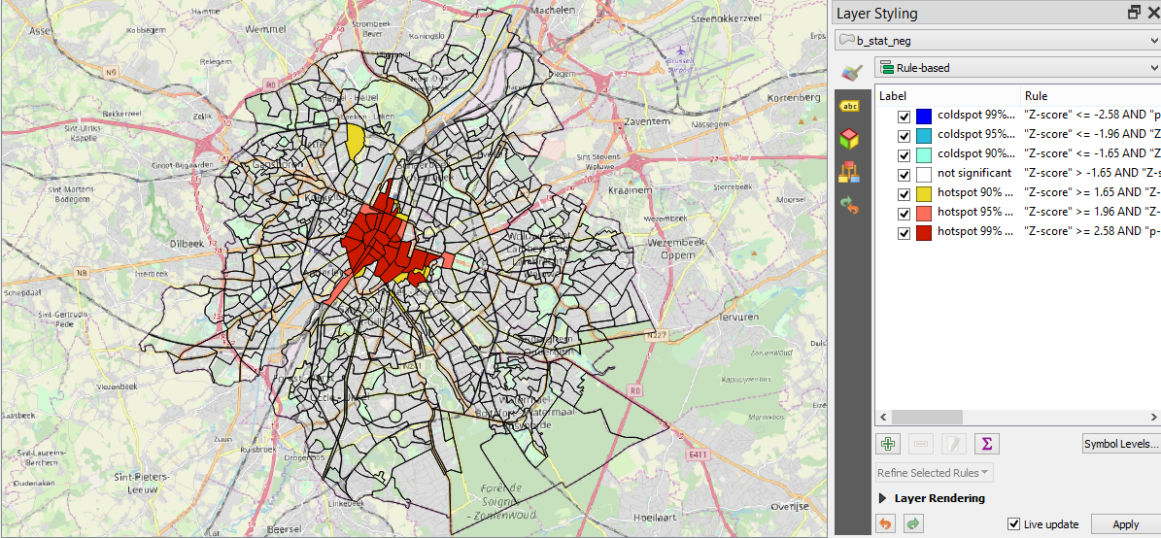

1. The result depicted in Figure xx is based on **standard deviation** (diversity indicator) analysis with grid of 250 meters.

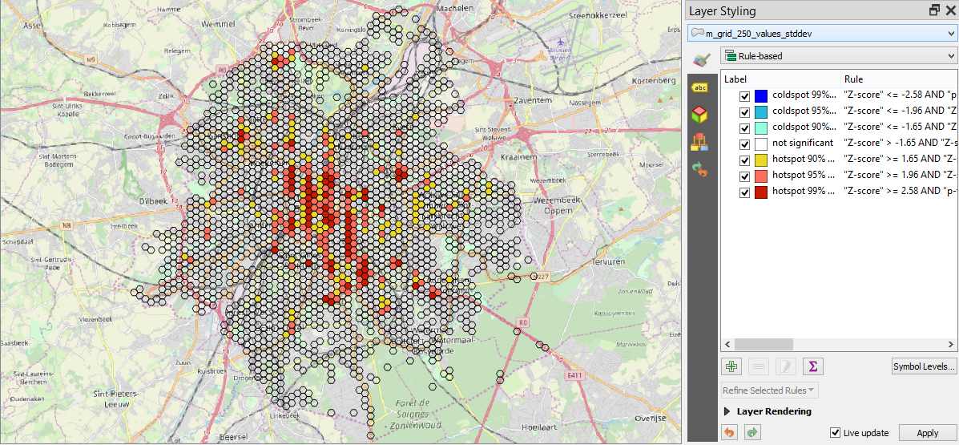

**Hot/Cold Spot Analysis for Munich**

1. The result represented in Figure xx is the result of **Local Moran's I analysis**.

This is the analysis of clusters of high and low values and outliers, based on raw point data with point distance to it’s neighbours of 250 meters.

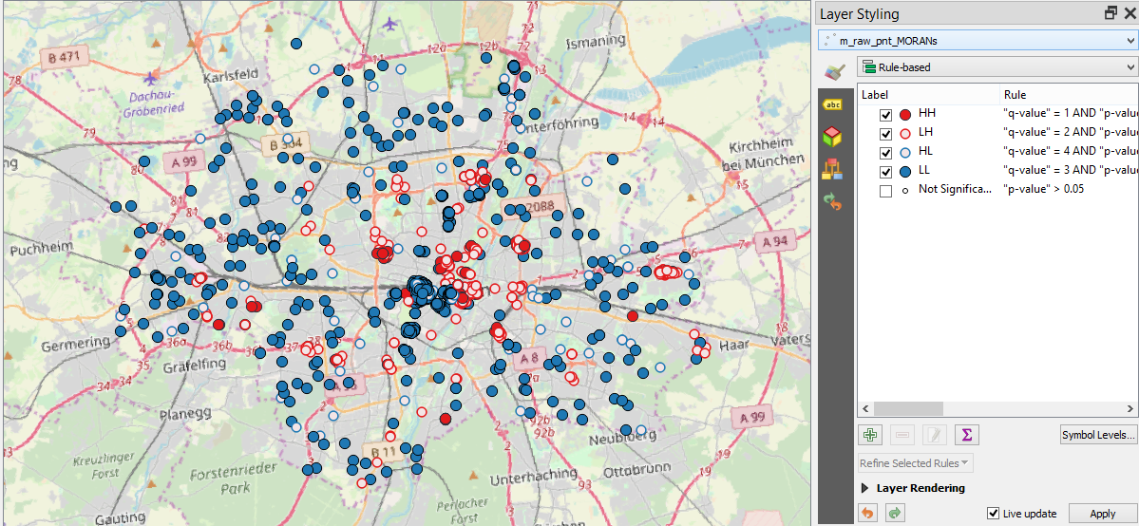

2. Figure xx presents the result of Hot / Cold Spot analysis based on **statistical units (districts)** only for **positive emotions**.

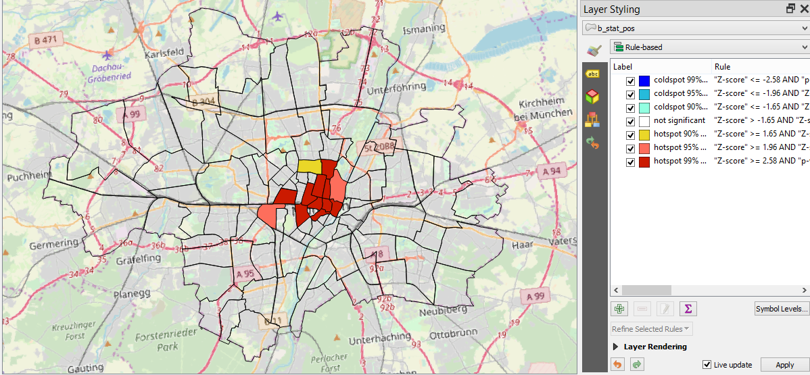

3. Figure xx presents the result of Hot / Cold Spot analysis based on **statistical units (districts)** only for **negative emotions**.

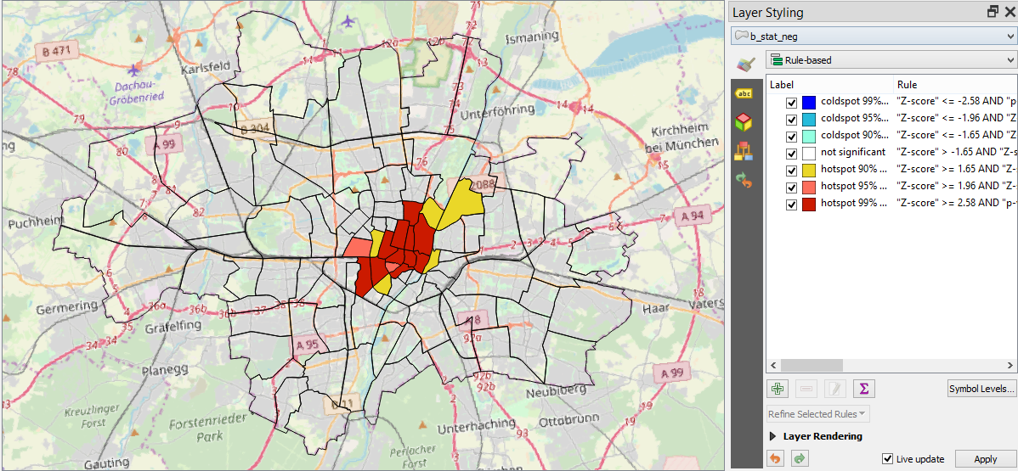

1. The result depicted in Figure xx is based on **standard deviation** (diversity indicator) analysis with grid of 250 meters.

